**Gas Location Project Proposal**

**OVEREVIEW**

The goal of this application is to help users find the most affordable gas within their chosen distance.

**GOALS**

1. Set up a user account.
2. Enable the user to discover the most economical gas options within a radius of their choosing.

**SPECIFICATIONS**

This project will utilize the follow two APIs.

https://positionstack.com/documentation

<https://collectapi.com/api/gasPrice/gas-prices-api>

In the first version of the project, users input their preferred location and distance radius, allowing the application to identify all available gas options within that radius. In the second version, the application will automatically determine the device's location and let users choose their preferred distance radius.

Nonetheless, the initial step entails users registering their login information, which will encompass the details presented in the table below.

The UI will look like the figure below.

Furthermore, there will be an additional table that stores all the locations they have previously selected.

**WORKFLOW**

The workflow is as flow below.

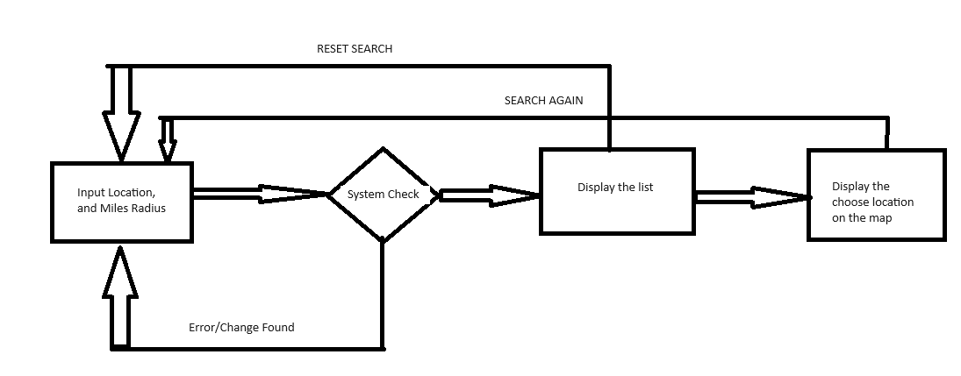

**FUNCTION FLOW**

In this project there are only two functions. Once is the search by radius and the second one is clear the search.



